A SURVEY PAPER ON SMART FARMING USING IOT

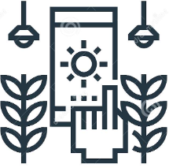

Sudharshan S, Sudharshan B, Sushil Kumar R, Vinoth N

*Jeppiaar College of Engineering, Jeppiaar Nagar,*

*Rajiv Gandhi Salai, Chennai- 600 119.*

*sushilkumar90228@gmail.com,silent.eyes.sudharshan.2001@gmail.com, sudharshan645@outlook.com, vinoth.n3000@gmail.com.*

**ABSTRACT**

***The growth of the global population coupled with a decline in natural resources, farmland, and the increase in unpredictable environmental conditions leads to food security is becoming a major concern for all nations worldwide. These problems are motivators that are driving the agricultural industry to transition to smart agriculture with the application of the Internet of Things (IoT) and big data solutions to improve operational efficiency and productivity. The IoT integrates a series of existing state of the art solutions and technologies, such as wireless sensor networks, cognitive radio ad hoc networks, cloud computing, big data, and end-user applications. This study presents a survey of IoT solutions and demonstrates how IoT can be integrated into the smart agriculture sector. To achieve this objective, we discuss the vision of IoT enabled smart agriculture ecosystems by evaluating their architecture (IoT devices, communication technologies, big data storage, and processing), their applications, and research timeline. In addition, we discuss trends and opportunities of IoT applications for smart agriculture and also indicate the open issues and challenges of IoT application in smart agriculture. We hope that the findings of this study will constitute important guidelines in research and promotion of IoT solutions aiming to improve the productivity and quality of the agriculture sector as well as facilitating the transition towards a future sustainable environment with an agro ecological approach.***

***KEYWORDS:*** *Internet of Things, Smart farming*

# INTRODUCTION:

# In order to meet the current global needs of humanity, new solutions and technologies are constantly being proposed and implemented. This has led to the advent of the Internet of Things. IoT is defined as the network of all objects that are embedded within devices, sensors, machines, software and people through the Internet environment to communicate, exchange information and interact in order to provide a comprehensive solution between the real world and the virtual world. In recent years, IoT has been applied in a series of domains, such as smart homes, smart cities, smart energy, autonomous vehicles, smart agriculture, campus management, healthcare, and logistics.

Over the years, wireless sensor networks (WSN) have been strongly applied in the agricultural sector, building the foundation for developing smart agriculture. The unique characteristics of WSN, such as the ability to self-organize, self-configure, self-establish, and self-recover, make it suitable for smart agriculture. The sensor device consists of a radio frequency (RF) transceiver, sensor, microcontroller and battery power. The WSN focuses on applications such as environmental monitoring, machine control automation and traceability

Iot in smart farming is useful in UAV farming, Monitoring Farm, Precision farming, tracking and tracing, supply chain management, analytic data and prediction.

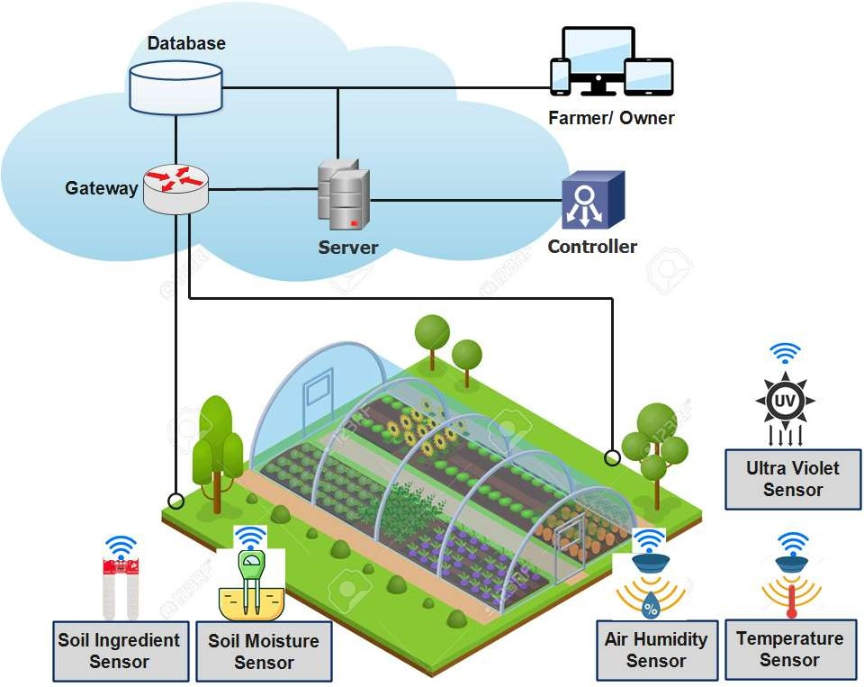

# LITERATURE SURVEY:

*Smart Farming Using IoT:*

IoT is an expanding network of physical devices that are linked with different types of sensors and with the help of connectivity to the internet; they are able to exchange data. Through IoT, internet has now extended its roots to almost every possible thing present around us and is no more limited to our personal computers and mobile phones.

Along with the development of science and technology, the urgent requirement for breakthrough solutions and technologies aiming at improving productivity and efficiency in the agriculture sector has led to adoption of the Iot. The primary motivation for their applications is the breakthrough progress of smart agriculture and its inevitable role as the future of smart and sustainable environment management. Iot integrates a series of existing solutions and technologies, such as WSN, cognitive radio, ad hoc networks, cloud computing, and end-user applications. In the smart agricultural sector, automation solutions and technologies, mechanical machines, knowledge, decision-making tools, services, and software are integrated seamlessly to help farmers improve productivity, product quality, and profitability.

The common architecture of an IoT device consists of sensors to collect information from the environment, actuators based on wired or wireless connections, and an embedded system that has a processor, memory, communication modules, input output interfaces and battery power.

*Communication Technology:*

The survey of communication technologies for IoT indicated that to integrate IoT into the smart agriculture sector, communication technologies must progressively improve the evolution of IoT devices. They play an important role in the development of IoT systems. The existing communication solutions can be classified as: protocol, spectrum, and topology.

Protocols: many wireless communication protocols have been proposed for the smart agriculture sector. Based on these protocols, devices in a smart agricultural system can interact, exchange information, and make decisions to monitor and control farming conditions and improve yields and production efficiency. The typical, low-power communication protocol numbers commonly used in smart agriculture can be divided into short-range and long-range categories based on the communication range.

# SENSORS USED:

Sensors used in agriculture for smart farming are known agriculture sensors. They **provide data that helps farmers to monitor and optimize crops with environmental conditions and challenges**. These sensors in agriculture installed and fixed in weather stations, drones, and robots used in the agriculture industry.

1. Soil moisture sensor:

Soil moisture sensors **measure the water content in the soil and can be used to estimate the amount of stored water in the soil horizon**. Soil moisture sensors do not measure water in the soil directly. Instead, they measure changes in some other soil property that is related to water content in a predictable way.

1. Temperature sensor:

A temperature sensor is **a device that detects and measures hotness and coolness and converts it into an electrical signal**.

1. Ultraviolet sensor:

The UV Sensor is **used for detecting the intensity of incident ultraviolet(UV) radiation like UV radiation in sunlight**. This form of electromagnetic radiation has shorter wavelengths than visible radiation. This module is based on the sensor GUVA-S12SD and SGM8521 Opamp, which has a wide spectral range of 200nm-370nm

*Applications and Benefits of Using Smart Farming:*

In recent years, a series of IoT applications for agriculture have been introduced. According to survey results, we divided these applications into categories based on their purpose, including monitoring, tracking and traceability, and greenhouse production.

# APPLICATIONS:

*Monitoring:*

In the agriculture sector, factors affecting the farming and production process can be monitored and collected, such as soil moisture, air humidity, temperature, pH level, etc. These factors depend on the considered agricultural sector.

Monitoring information, such as soil condition, moisture, and temperature, and the prediction of natural factors, such as rainfall and weather, support the control of growing conditions of crops, helping farmers plan and make irrigation decisions to optimize production and reduce labour costs. In addition, the collected data, combined with big data processing technology, can provide recommendations for implementing preventive and remedial solutions against pests and diseases in farming.

*Smart Precision Farming:*

The advent of the GPS (global positioning system) has created breakthrough advances in many fields of science and technology. The GPS provides the most important parameters for locating a device, such as location and time. suitable farming maps have been established for fields and farms. As a result, agricultural machinery and equipment can be operated autonomously.

In smart precision farming, one of the most important applications is the use of drones in monitoring and farming activities. Some common farming tasks using UAVs include spraying pesticides, fertilizing, sowing seeds, evaluating and mapping, and monitoring crop growth. IT presented a detailed survey of drone applications for smart agriculture, including applications, control technology, and future trends of the UAV application for smart agriculture.

**

*Greenhouse Production:*

A greenhouse consists of walls and a roof, which are usually made from transparent materials, such as plastic or glass. In a greenhouse, plants are grown in a controlled environment, including controlling for moisture, nutrient ingredients of the soil, light, temperature, etc.

Introducing an energy-saving temperature control technology for smart greenhouses. This study proposed two intelligent control methods: active disturbance rejection control and fuzzy active disturbance rejection control. The experimental results demonstrate that the proposed technology saves over 15% of the total energy consumption of the greenhouse.

IoT-based greenhouse environmental monitoring system for multipoint monitoring in large greenhouses. Instead of using multiple sensors at different locations, this solution involves a drive system that allows the sensor system to move to different locations in the greenhouse.

***Benefits:***

* It allows farmers to maximize the yield using minimum resources.
* Increase agility of the process.
* Find significant change in weather, humidity, air quality..
* Lower food prices.
* Soil quality and moisture.
* Cost-effective installation.
* Crop growth status.

# CONCLUSION AND FUTURE WORK:

In this study, we presented an overview of IoT and big data for the smart agriculture sector. Several issues related to promoting IoT deployment in the agriculture sector have been discussed in detail. Survey results indicate that many studies have been performed to apply IoT for smart agriculture, aiming to enhance productivity, reduce human labour, and improve production efficiency. The benefits of applying IoT and big data in agriculture were discussed. In addition, we also pointed out the challenges we need to overcome to be able to accelerate the deployment of IoT in smart agriculture. However, there are still some challenges that need to be addressed for IoT solutions to be affordable for the majority of farmers, including small- and medium-scale farm owners. In addition, security technologies need to be continuously improved, but in our opinion, the application of IoT solutions for smart agriculture is inevitable and will enhance productivity, provide clean and green foods, support food traceability, reduce human labour, and improve production efficiency. On the other hand, this survey also points out some interesting research directions for security and communication technologies for IoT. We think that these will be very exciting research directions in the future.



# REFERENCES:

# Quy, V.K.; Nam, V.H.; Linh, D.M.; Ngoc, L.A.; Gwanggil, J. Wireless Communication Technologies for IoT in 5G: Vision, Applications, and Challenges. *Wirel. Commun. Mob. Comput.* 2022, *2022*, 3229294.

1. **Sinche, S.; Raposo, D.; Armando, N.; Rodrigues, A.; Boavida, F.; Pereira, V.; Silva, J.S. A Survey of IoT Management Protocols and** **Frameworks. *IEEE Commun. Surv. Tutor.* 2020, *22*, 1168–1190.**

# Elijah, O.; Rahman, T.A.; Orikumhi, I.; Leow, C.Y.; Hindia, M.N. An Overview of Internet of Things (IoT) and Data Analytics in Agriculture: Benefits and Challenges. *IEEE Internet Things J.* 2018, *5*, 3758–3773.

# An, J.G.; Le Gall, F.; Kim, J.; Yun, J.; Hwang, J.; Bauer, M.; Zhao, M.; Song, J.S. Toward Global IoT-Enabled Smart Cities Interworking Using Adaptive Semantic Adapter. *IEEE Internet Things J.* 2019, *6*, 5753–5765.

# Ammad, M.; Shah, M.A.; Islam, S.U.; Maple, C.; Alaulamie, A.A.; Rodrigues, J.J.P.C.; Mussadiq, S.; Tariq, U. A Novel Fog-Based Multi-Level Energy-Efficient Framework for IoT-Enabled Smart Environments. *IEEE Access* 2020, *8*, 150010–150026.

# Citoni, B.; Fioranelli, F.; Imran, M.A.; Abbasi, Q.H. Internet of Things and LoRaWAN-Enabled Future Smart Farming. *IEEE* *Internet Things Mag.* 2019, *2*, 14–19.

# Yang, X.; Shu, L.; Chen, J.; Ferrag, M.A.; Wu, J.; Nurellari, E.; Huang, K. A Survey on Smart Agriculture: Development Modes, Technologies, and Security and Privacy Challenges. *IEEE/CAA J. Autom. Sin.* 2021, *8*, 273–302.

# Ayaz, M.; Ammad-Uddin, M.; Sharif, Z.; Mansour, A.; Aggoune, E.-H.M. Internet-of-Things (IoT)-Based Smart Agriculture: Toward Making the Fields Talk. *IEEE Access* 2019, *7*, 129551–129583.

# Friha, O.; Ferrag, M.A.; Shu, L.; Maglaras, L.; Wang, X. Internet of Things for the Future of Smart Agriculture: A Comprehensive Survey of Emerging Technologies. *IEEE/CAA J. Autom. Sin.* 2021, *8*, 718–752.

# Farooq, M.S.; Riaz, S.; Abid, A.; Abid, K.; Naeem, M.A. A Survey on the Role of IoT in Agriculture for the Implementation of Smart Farming. *IEEE Access* 2019, *7*, 156237–156271.